Import Certificate Steps

**Location of the Java Trust-store:** C:\Program Files\Java\jdk1.8.0_211\jre\lib\security\cacerts

**Steps to Import a Certificates:**

1. Download and store the certificate files in a specific location

From ip download 3 cert,

1. Open CMD in admin mode
2. Go to :\Program Files\Java\jdk1.8.0_211\bin
3. Run keytool command –

|  |
| --- |
| keytool -importcert -keystore cacerts -storepass changeit -file E:\Certs\PMUSA_SMWE_SWG_SSL.cer -alias "proxy-SMWESSL" |

Type of Certificates to be Imported:

1. Proxy Certificates – Completed

<https://10.13.250.20:8082/SSL/Download_CA>

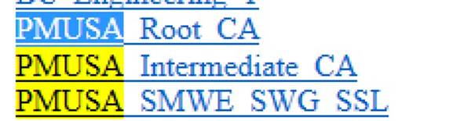

1. ServiceNow Certificates – TBD
   1. Need to be downloaded from ServiceNow production portal
   2. <https://www.ssllabs.com/ssltest/analyze.html?d=smwe.service%2dnow.com&hideResults=on&latest>
2. 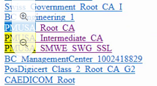

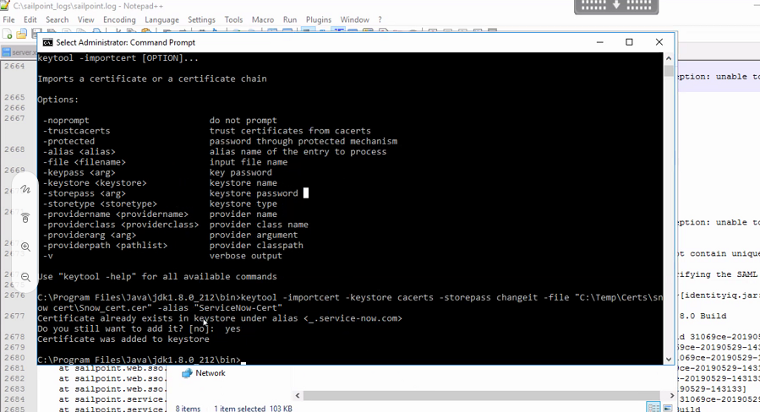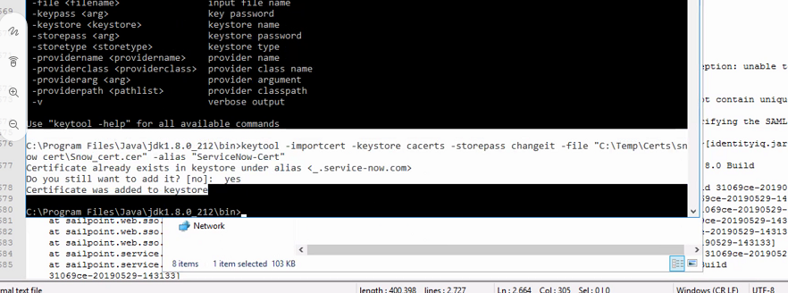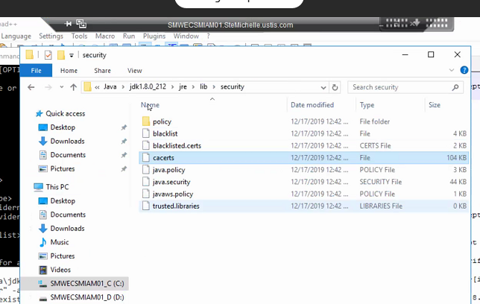

Prod iam01

